Roll no: 241701021

Computer Networks Exercise 1

Aim:
To connect end devices with hub through copper straight through.

Ball diagram:

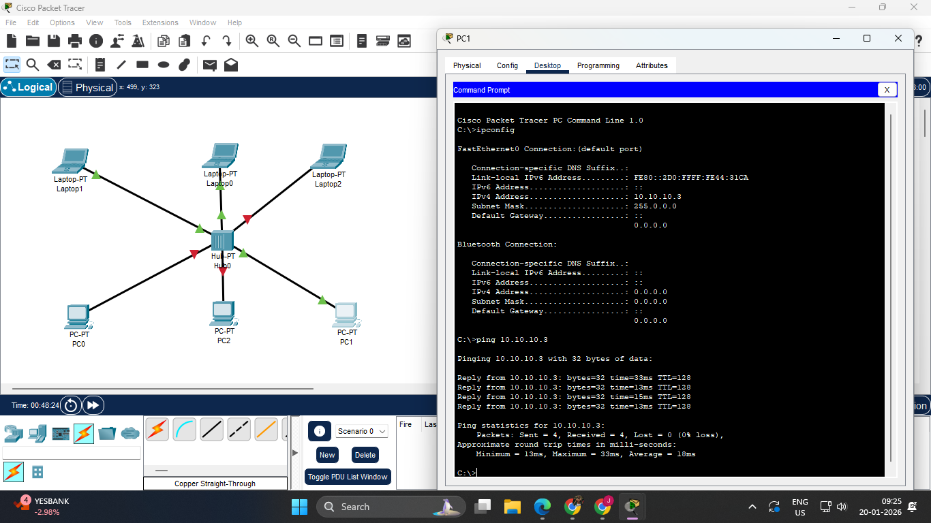

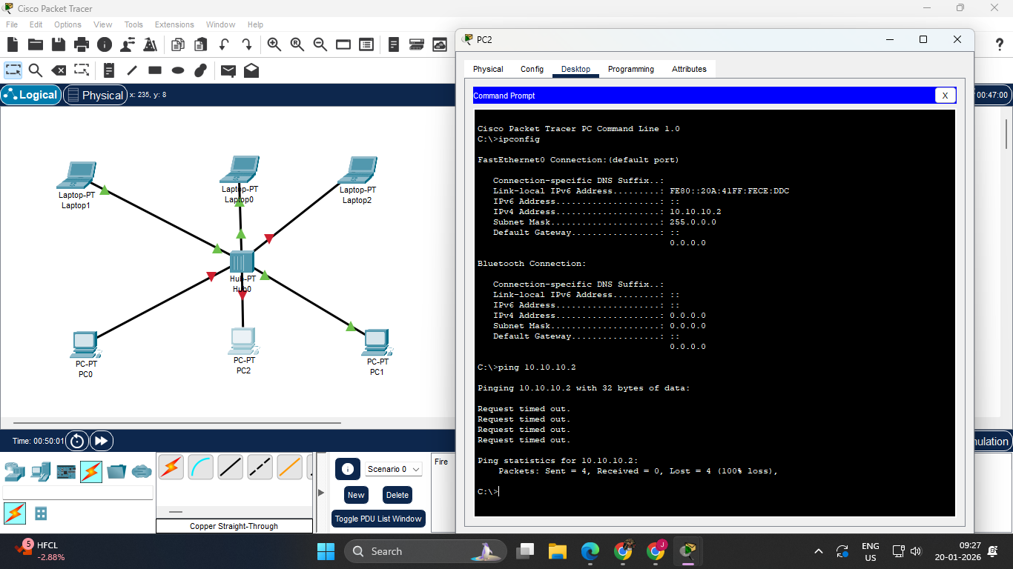
Components Required:
- 1 Hub
- 3 Desktop
- 3 laptop
- 6 Copper straight through

Procedure:

- Place the PT Hub in the middle of the screen from the components provided.
- Place 6 End Devices around the PT Hub. It may be either a PC or a Laptop.
- Connect the End Devices to the PT Hub using Copper Straight-Through wires through Fast Ethernet.
- Click on each of the End Devices, go to Desktop and set the respective IP addresses in the IPv4 address tab.
- Rename the End Devices as per their respective IP addresses.
- Now, we can click on any End Device, go to Command Prompt in the Desktop tab and type in commands to view the ip configuration, to ping, etc.

Result:
Thus connection Hub between end devices Through a copper straight through has been executed successfully.

